- Purpose
  - The purpose of this document is to describe the procedure for assembling the Head Lift on the Genesys Machine.
- Scope
  - This SOP applies to all equipment assembly team members. The process applies to the following machine ID’s:
EP50321EQS0600BE1200 – Head Lift Assembly
- Responsibilities
  - The operations manager/supervisor is responsible for enforcing this SOP.
- Materials
  - The proper materials needed for this process are listed on the machine work order.
- Definitions

- Procedure
  - Take an actuator spring bracket (E28726) and attach a switch cam (E29002) in the three locations shown using a cam mounting plate (E29010), 2 toothed washers (E28821), and 2 screws (E28779) on each. Leave them loose at this point.
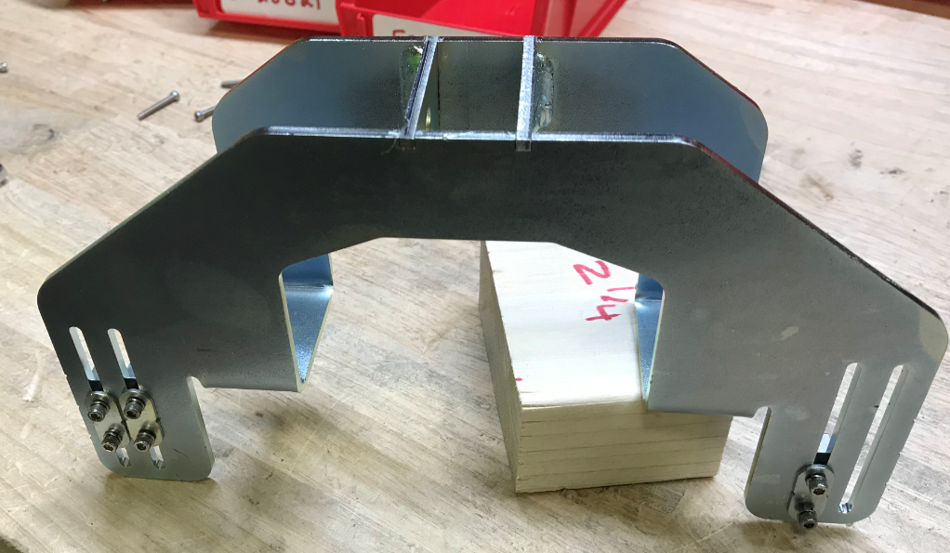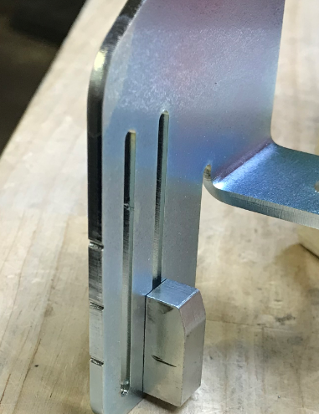

  - Start with an actuator mounting bracket (E29000). Take a microswitch (E20704) and a switch mounting plate (E29009). Place the switch onto the mounting plate and attach it to the bracket using a screw (E28779) through the plate only, 2 screws (E28769) through the switch and plate, 3 toothed washers (E28821), 3 flat washers (E29368), and 3 hex nuts (E28770). The toothed washers go under the bolt head while the flat washers go under the nut. Install it onto the correct side of the bracket. Leave it loose at this point so the switches can be adjusted.
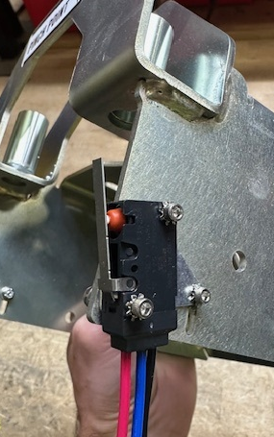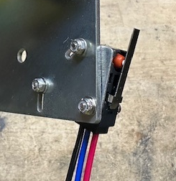
  - On the other side of the bracket, attach 2 microswitches (E20704) and a mounting plate (E29009) using a screw (E28779) through the plate only, 2 screws (E28782) through the switch and the plate, 3 lock washers (E28821), 3 flat washers (E29368), and 3 hex nuts (E28770). The toothed washers go under the bolt head while the flat washers go under the nut. Leave it loose at this point so the switches can be adjusted.
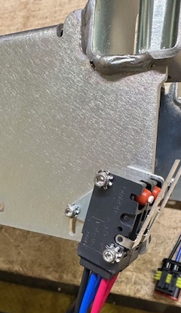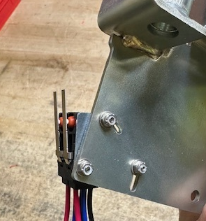
  - Take an actuator (E28628) and attach it in the appropriate location shown. Install a plastic washer (E83145) onto one side of the mounting clevis. If more than 1 can be fit in, then do it. Use a pin (E29003) to attach it. Secure it in place with a cotter pin (E28847).
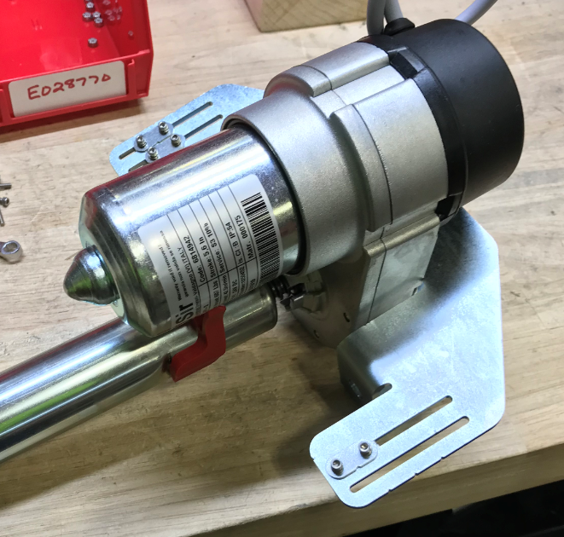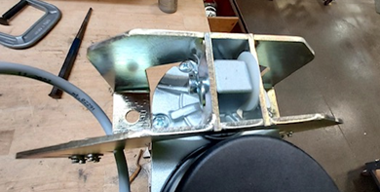
  - Take 2 springs (F091510) and place the springs over each of 2 shoulder bolts (E28730).
  - Place a washer (E29005) onto the bolts. Spread some grease onto the bolts in the area shown.
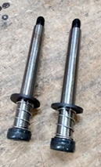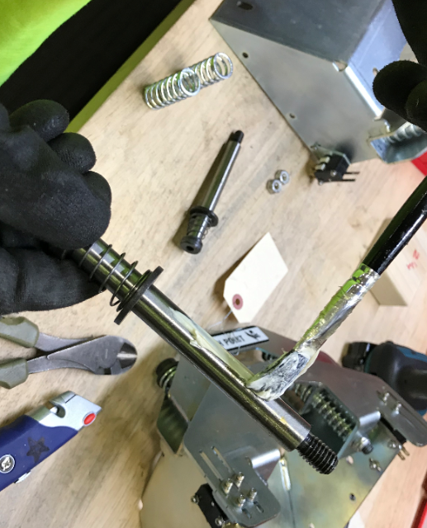
  - Use ½” reamer bit to clear sleeve from burrs and obstructions. Place a compression spring (E28727) over each sleeve on the mounting bracket.
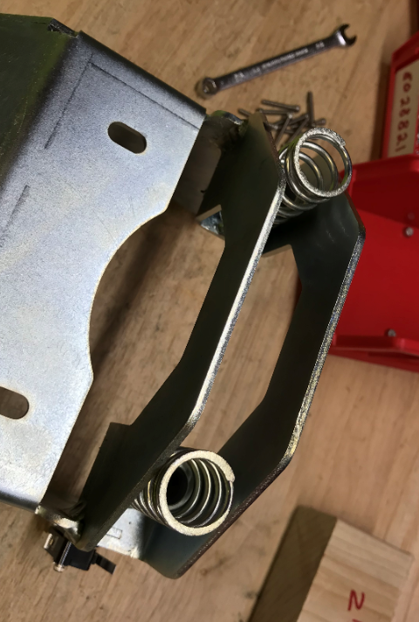

  - Put each shoulder bolt through one of the sleeves. Flip the assembly over.
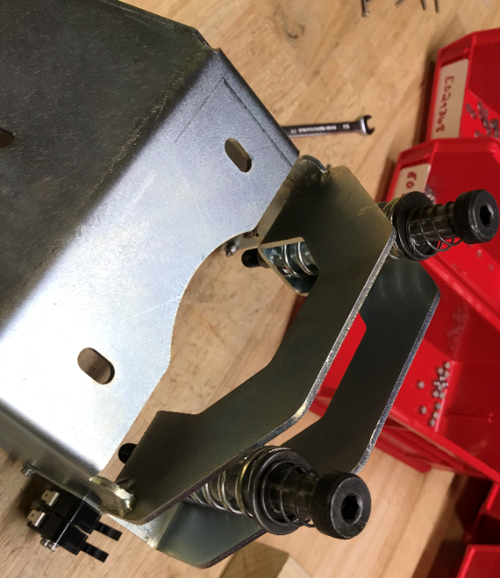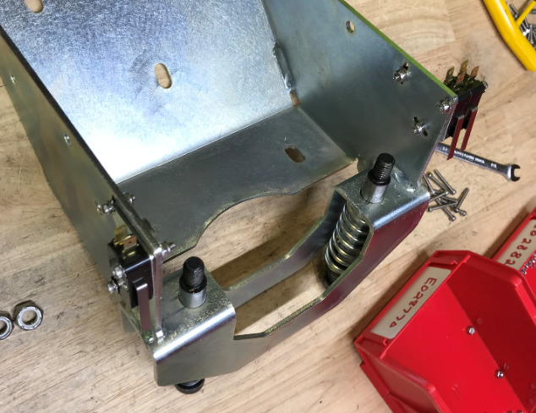
  - Place another compression spring (E28728) over the shoulder bolts on the bottom side of the mounting bracket.
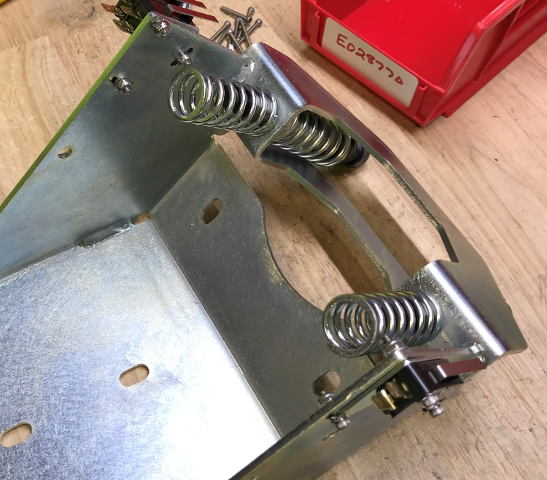

  - Place the threaded ends of the bolts through the holes on the actuator spring plate. This will sandwich the springs in place.

  - Fasten the assembly together using a nylock nut (E29393) on each bolt.
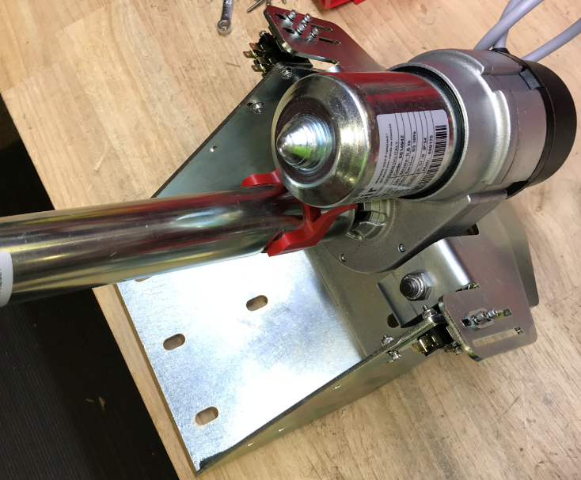
  - Set the switch position on the side with 2 switches. Slide both cams all the way up in the slot as shown. Place a 0.040” shim on the surface of the cams as shown. Rotate the switches into the cam until there is no more travel on the arm.

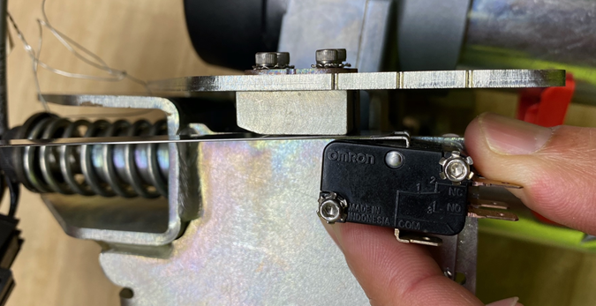
Switch Rotation
Arm fully depressed
Shim
Cam

  - Tighten the bolts in order 1 – 2 – 3 based on the diagram below.

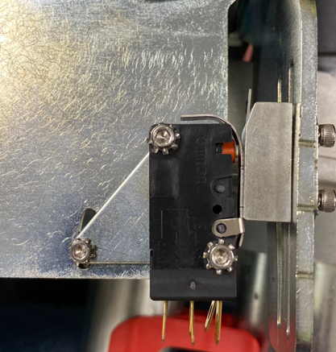
1
2
3

  - Repeat switch adjustment on the other side (Down Pressure 3 switch) using a 0.060” shim (single switch side).
  - Place a Pinch Point decal (E28796) onto the spring plate as shown.
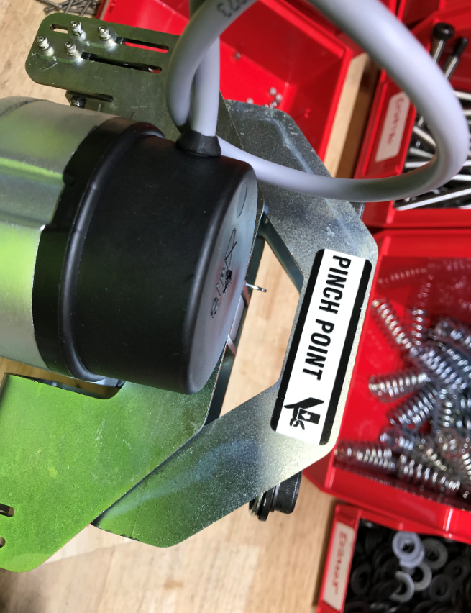

- References (optional section as needed)

- Training Guide

Functional Training Groups Requiring Training
Equipment Assembly Group

- SOP Change Control

Date of Change | Reason for Change
TBD | This is the first version of the S.O.P. hence there are no revisions to this document.
8/13/2021 | Added QC Checks
11/7/2023 | Updated to current process
5/12/2025 | Corrected part number and shim size

Approvals

Submitter/Author Approval:__________________________________ Date:______________________

Management Approval:______________________________________ Date:______________________

QAU Approval:_____________________________________________ Date:______________________

